**Spring**

5 layers in any enterprise application:

1. Presentation Layer
2. Controller Layer
3. Business Layer
4. Service Layer
5. Data Layer

By using struts, we can prepare only presentation and controller layer, but by using spring we can prepare all layers using different modules.

We can combine spring with combination any other frame work.

* By Rod Johnson

**Spring 5: In 2017**

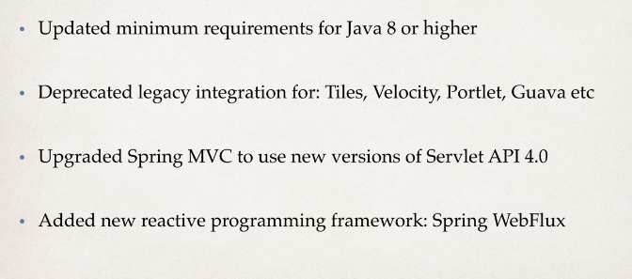

**Documentation:** [**www.spring.io**](http://www.spring.io)

* Light weight development with java Pojo’s.
* Dependency injection to promote loose coupling.
* Declarative programming with **Aspect-oriented programming(AOP**).
* Minimize boilerplate java code.

**Inversion of control:**

* It is design process for construction and management of objects.
* Outsource to object factory

**Spring Container: (**generally known as **Application Context**)

* Create and manage objects (IOC)
* Dependency Injection: Inject objects dependencies

**Configuring Spring Container:**

* **XML**
* **Java Annotations**
* **Java Source Code**

**Spring bean:**

* In spring, the objects in your application that are managed (Instantiated and assembled) by spring IOC container called beans.

**Dependency Injection:**

* Spring has an object factory that will build an object and inject all dependencies to it.
* The client delegates call to another object for responsibility of providing its dependencies.
* There are many types of injections.
  + Constructor Injection
  + Setter Injection
  + Literal values Injection

The main benefits of IOC or dependency injection are −

* It minimizes the amount of code in your application.
* It makes your application easy to test as it doesn't require any singletons or JNDI lookup mechanisms in your unit test cases.
* Loose coupling is promoted with minimal effort and least intrusive mechanism.
* IOC containers support eager instantiation and lazy loading of services.

The three commonly used implementation of 'Application Context' are −

* **FileSystemXmlApplicationContext** − This container loads the definitions of the beans from an XML file. Here you need to provide the full path of the XML bean configuration file to the constructor.
* **ClassPathXmlApplicationContext** − This container loads the definitions of the beans from an XML file. Here you do not need to provide the full path of the XML file but you need to set CLASSPATH properly because this container will look bean configuration XML file in CLASSPATH.
* **WebXmlApplicationContext** − This container loads the XML file with definitions of all beans from within a web application.

Following is sequence of a bean lifecycle in Spring −

* **Instantiate** − First the spring container finds the bean's definition from the XML file and instantiates the bean..
* **Populate properties** − Using the dependency injection, spring populates all of the properties as specified in the bean definition.
* **Set Bean Name** − If the bean implements BeanNameAware interface, spring passes the bean's id to setBeanName() method.
* **Set Bean factory** − If Bean implements BeanFactoryAware interface, spring passes the beanfactory to setBeanFactory() method.
* **Pre-Initialization** − Also called postprocess of bean. If there are any bean BeanPostProcessors associated with the bean, Spring calls postProcesserBeforeInitialization() method.
* **Initialize beans** − If the bean implements IntializingBean,its afterPropertySet() method is called. If the bean has init method declaration, the specified initialization method is called.
* **Post Initialization** − If there are any BeanPostProcessors associated with the bean, their postProcessAfterInitialization() methods will be called.
* **Ready to use** − Now the bean is ready to use by the application.
* **Destroy** − If the bean implements DisposableBean , it will call the destroy() method .

**Bean Scope:** how long it will live and how many instances are created.

* Singleton: by default
  + One instance of the bean in cache
  + All requests for the bean will return a shared reference to same bean.
  + Can specify by using **scope=” singleton”**
  + Stateless data
* Prototype:
  + New instance for each request.
  + Can specify by using **scope=” prototype”**
  + can keep track of stateful data.

**Bean Life Cycle:**

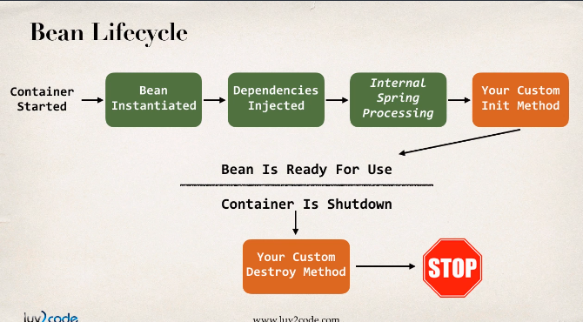

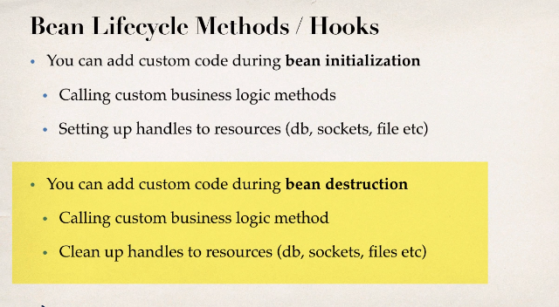

* We can provide additional details in XML configuration like **init-method and destroy-method**
* **Access modifier**  
  The method can have any access modifier (public, protected, private)
* **Return type**  
  The method can have any return type. However, "void' is most commonly used. If you give a return type just note that you will not be able to capture the return value. As a result, "void" is commonly used.
* **Method name**  
  The method can have any method name.
* **Arguments**  
  The method cannot accept any arguments. The method should be no-arg.

**Note**: for prototype scoped beans, spring does not call destroy methods. Spring does not manage the complete life cycle of a prototype bean, just the container instantiates, configures and hands it to client with no further records of the instance. This means client code must clean up prototype scoped bean object and release the resources.

**Configuration with Annotations:**

* Special labels or markers that are added to java classes which provide meta-data about the class.
* They can be processed at compile time or run time.
* Xml configuration is verbose.
* Minimizes the Xml configuration
* **Spring will scan java classes for special annotations, if it finds register those beans in spring container.**

**@Component: register spring bean automatically.**

**Spring Auto Wiring:**

* Spring looks for the class that matches the property by type and will inject it automatically.
* Three types of injections:
  + Constructor Injection
  + Setter Injection
  + Field Injections: sets values using java technology called reflection.

**@Autowired Annotation:**

**It is optional if the target bean defines one constructo**r to begin with. If there are several constructors at least one must be annotated to tell the constructor which one to use.

**@Qualifier Annotation:**

We use this annotation to tell spring which implementation it should use for the dependency injection.

* Spring uses the **Java Beans Introspector** to generate the default bean name.

If the annotation's value doesn't indicate a bean name, an appropriate name will be built based on the short name of the class (with the first letter lower-cased).

For example:

HappyFortuneService --> happyFortuneService

However, for the **special case of when BOTH the first and second characters of the class name are upper case**, then the **name is NOT converted**.

For the case of RESTFortuneService

RESTFortuneService --> RESTFortuneService

*No conversion* since the first two characters are upper case.

**@Scope:** to define the scope of bean object.

**@PostConstruct and @PreDestroy Method Signatures:**

* postConstruct annotation is used for init method. This method will be executed after the general process of the bean class.
* When Spring creates the beans it follows this general process
  + 1. Construct an instance of class  
    2. Inject dependencies  
    3. Set properties etc (@Value)
* preDestroy is used for destroy method and it is called when we close the context object.
* Java based configuration option enables you to write most of your Spring configuration without XML but with the help of few Java-based annotations.
* For example: Annotation **@Configuration** indicates that the class can be used by the Spring IoC container as a source of bean definitions. The **@Bean**annotation tells Spring that a method annotated with @Bean will return an object that should be registered as a bean in the Spring application context.

**@Repository:** Applied to DAO implementations for component scanning and exception translation.

**@GetMapping:** Takes only get requests.

**@PostMapping:** Accepts post requests.

**Purpose of Service layer:**

1. **Service Facade** design pattern.
2. Intermediate layer of custom business logic.
3. Integrate data from multiple sources (DAO/repositories).

**@Service:** applied to service implementations. (generally, defines transactional layer).

**SpringAOP**

**Aspect oriented programming:**

* Means Cross-Cutting Concerns (logics/functionalities).
* Aspect can be reused at multiple locations. Create Aspect at one location and can be used at all other locations.
* we can use advices in aspect class that can be used for many DAO classes by writing at a single location(class). If we call the target method, these aspect method spy on the method call in the background using pointcut expressions and executes before or after the target method executions.
* **Use Cases: (spying in and tracking message traffic to get details)**
  + Most commonly logging, security and transactions.
  + Audit logging.
  + Exception handling and can notify DevOps team via SMS/Email.
  + API Management**:** How many times a method is called or analytics like peak times and average load and top user.

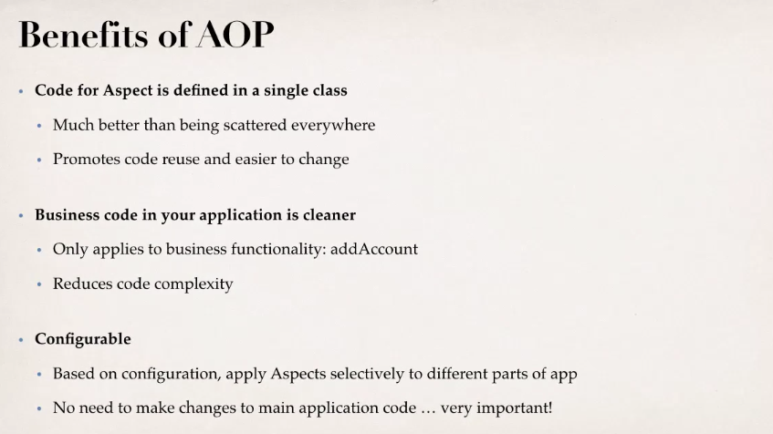

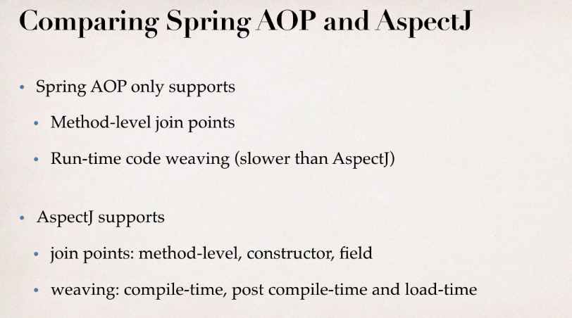

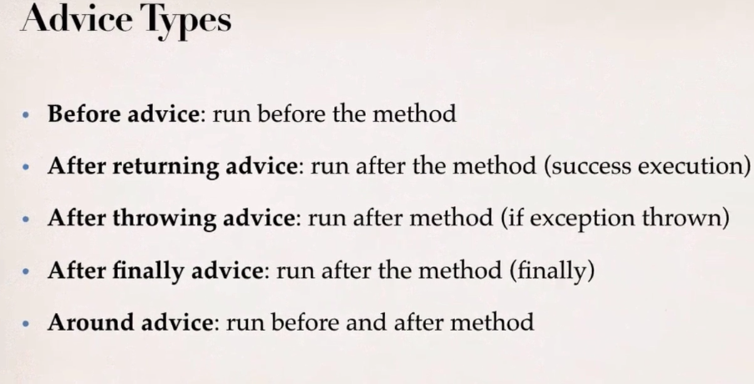

**@Aspect:** add it to aspect class for spying.

When we call the target method these AOP aspects listening in the in on the network and run the aspect methods.

**@Before**: can do all use cases. Add it to the method in aspect class, also mention the before which method it should run.

**Pointcut Expressions:** A predicate Expression where advice should be applied.

* Spring AOP uses **AspectJ pointcut Expression language**.

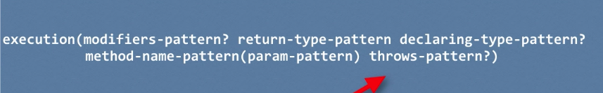

Ordering Aspects: **@order**

**JoinPoints :** To get method signature and parameters values.

**@AfterReturning**: can do all use cases. Also, can post process the data before returning.

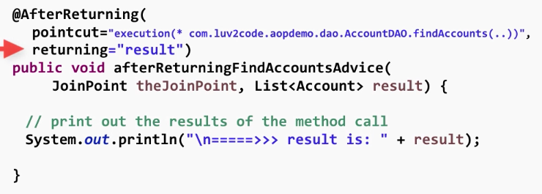

**@AfterThrowing:** We can log the exception and perform auditing. Also, can notify the DevOps team.

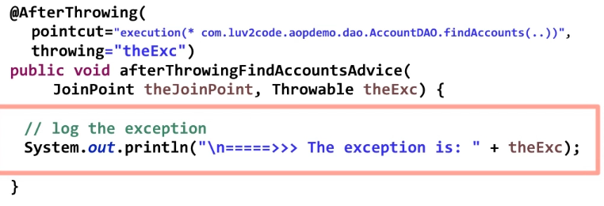

This exception is propagated back to the calling method. If you want to stop the exception propagation use the @Around advice.

**@After:** runs for both success or failure.

**@Around:** Makes call before and after method call.

* Generally used for logging auditing and security, pre and post processing of data.
* Instrumentation and managing Exceptions.

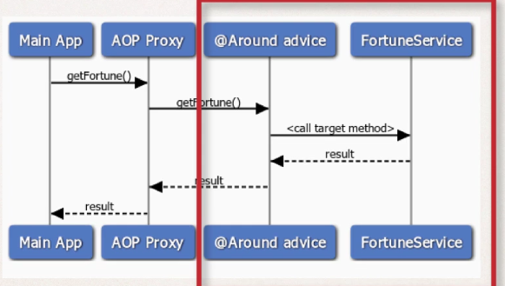

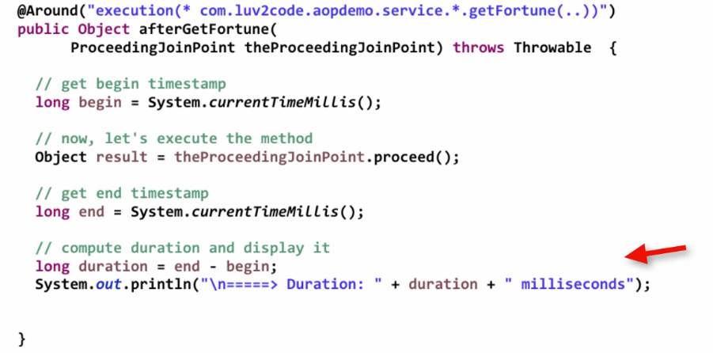

**Spring REST**

* Representational state transfer. (calls made over HTTP)
* Lightweight and commonly use XML and JSON.

JSON Data Binding:

* Spring uses **Jackson** for this.
* Jackson will call appropriate getters and setters for conversion to POJO.

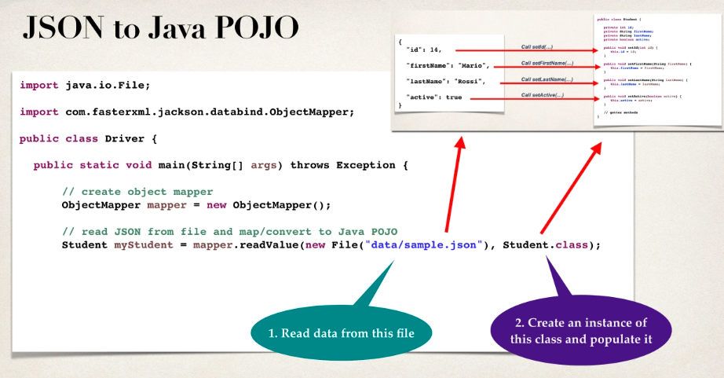

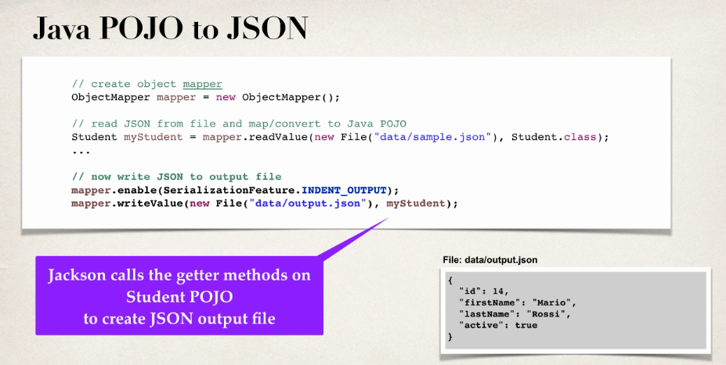

* When building Spring REST applications, Spring will automatically handle Jackson integration. It will convert JSON data passed to REST controller in to POJO and java object returned from REST controller to JSON.
* We can ignore the unknown properties by mentioning @JsonIgnoreProperties(ignoreUnknown = true)

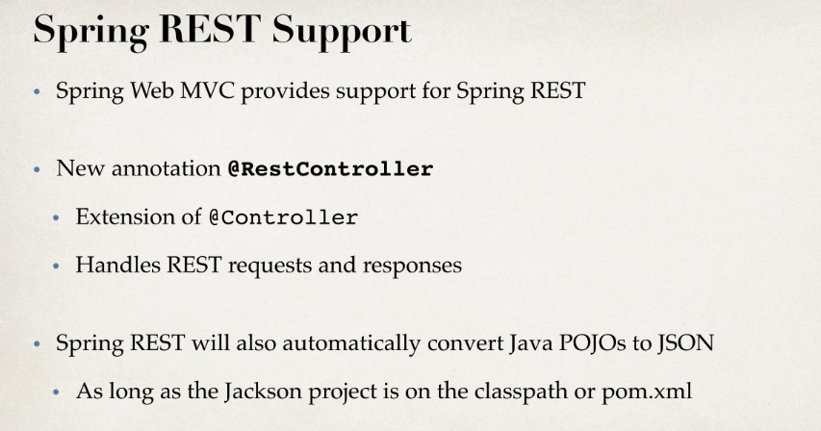

* @RestController 🡺@Controller, @ResponseBody

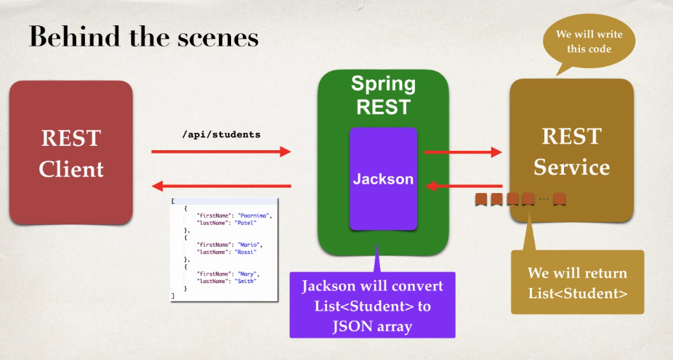

**@PathVariable**: To retrieve single object based on the path variable. Gets data from URI.

**@PostConstruct:** To load the data only once.

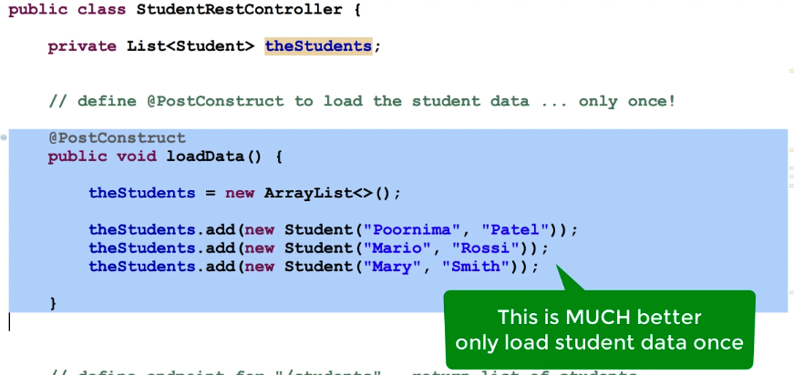

**Spring Rest Exception Handling:**

**@ExceptionHandler:** This will return a ResponseEntity.

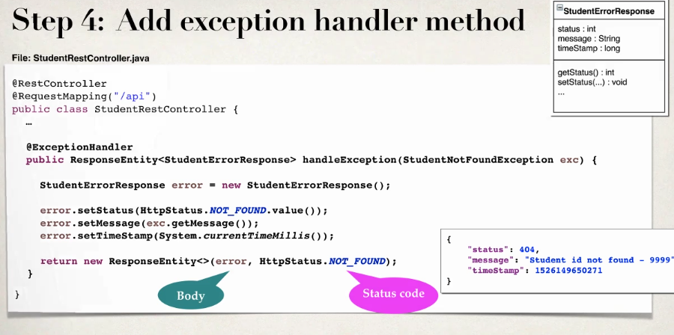

We can also add generic exception handler to handle any type of exceptions in the service.

**Global Exception handlers:** As exception handlers are specific to REST controller, code can’t be reused. So, we need global exception handlers to centralize exception handling.

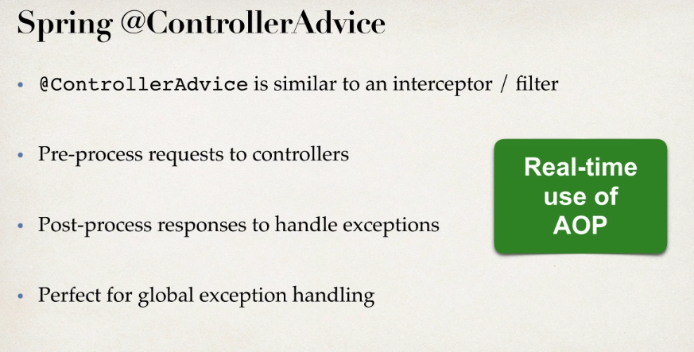

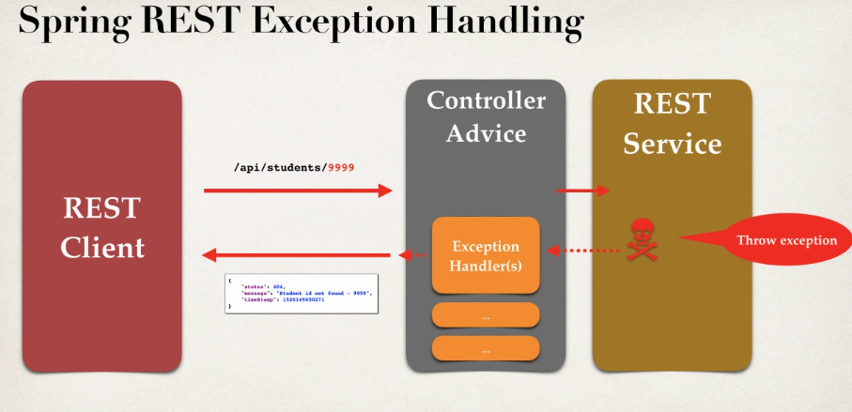

**REST API Design:**

* By reviewing API requirements
* By identifying main resource/entity
* By using HTTP methods to assign actions on resource.

**@RequestBody:** To access JSON as POJO

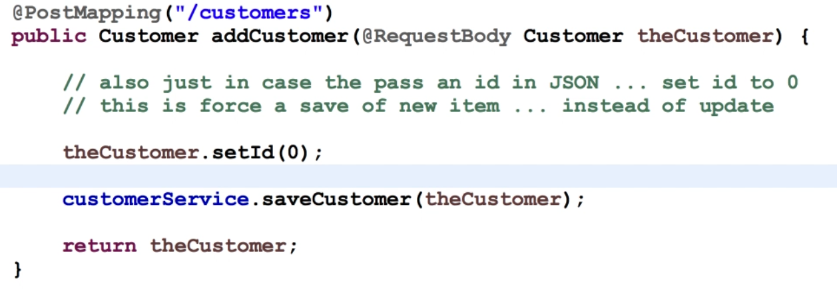

**REST Vs SOAP:**

1. SOAP is a **format of XML**, where as REST is an **architectural style** (Rest is just a style of how you design resources and expose them using HTTP).
2. **Data exchange format:** In SOAP it is XML, both request and response should adhere to SOAP structure. Where as in REST no strict exchange format. Can you XML, JSON or any other format.
3. **Service Definitions:** SOAP uses WSDL(web service definition language). Whereas REST doesn’t have any standards, can use WADL(web application definition language) which is not popular or **Swagger**, which is one the popular web service definition language for REST.
4. **Transport:** for SOAP we can use HTTP or MQ. Where REST is specific to HTTP protocol.
5. **Ease of Implementation:** RESTful services are typically easier to implement. Easy to parse JSON and not mandatory to implement service definition.

* Spring Boot auto configures the dispatcher servlet found on class path, also configures Error MVC, Error Controllers and default View resolvers.
* It auto configures what all found on class path based on dependencies.

**Dispatcher Servlet:**

* Dispatcher servlet is the one handling all the requests, by default it is configured to root {/}. This follows a pattern **called Front Controller**, here dispatcher servlet is the front controller for Spring Web MVC framework. Dispatcher servlets knows all mappings in the application. By looking at the URI and request method dispatcher servlet handles request to respective controller and method.
* **@ResponseBody** annotation is used to convert the resultant bean to message format. Here we use Jackson conversion. Dispatcher servlet invokes the conversion on it.

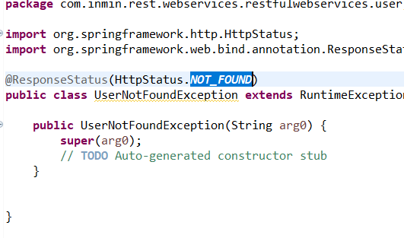**@ResponseStatus:** This is used to set the return status of the request manually if something goes wrong.

**This will return 404 Not Found instead of 500 internal server error.**

* We can use this default error handling that will be provided by the combination of spring boot and spring MVC framework.
* Below is the simple returned exception by one of the services. Each of service defines structure for the exceptions in different way. There should be standard common structure for defining the all exceptions in organizations.

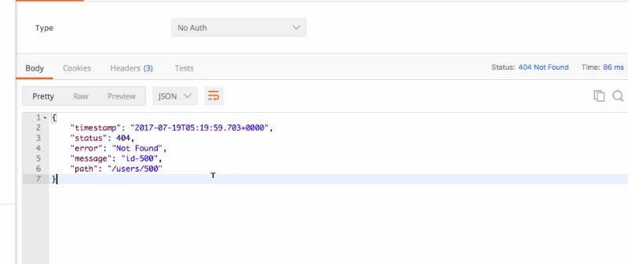

* Need to extend ResponseEntityExceptionhandler class and override methods in order generate customized exception formats.

**@ControllerAdvice:** When we want to share things across multiple controllers, we use this. By using this we can handle @ExceptionHandler, @InitBinders to handle dates and @ModelAttribute when we want to share common models across controllers.

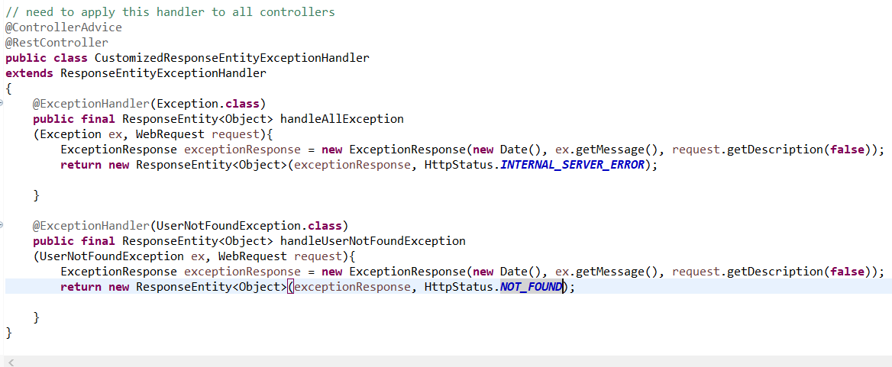

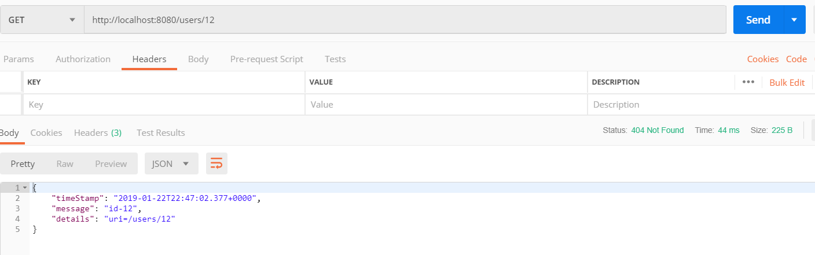

**Validation:**

* We would validate the bean, if it is invalid, we return proper response back.
* **@Valid:** It should be before @RequestBody and required validation annotations on variables od bean class, so that spring validates before creating a bean.
* we can override the handleMethodArgumentNotValid from ResponseEntityExceptionhandler class so that we can customize this error message for these validation failures.

**HATEOS:** Hyper media as the engine of application state. Returning some meta data about the services or any other information. Usually gives the link for other resources.

* Along with data of the user send other information using Hateos concepts.

**Internationalization(I18-N):** Customizing your services for different people around the world.

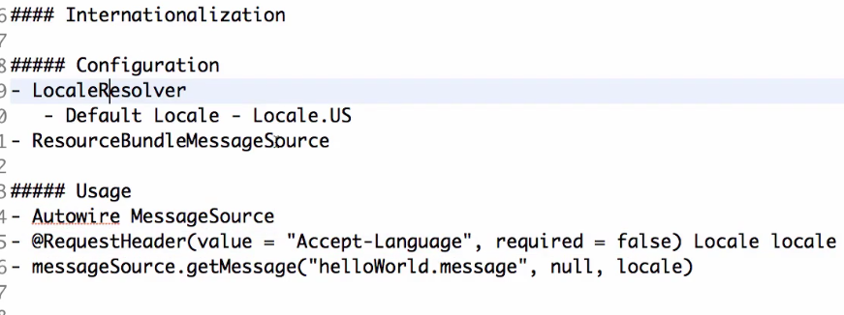

**Lecture 29**

**Content Negotiation:** Making application to respond on different format like XML instead of JSON. Just by adding the dependency for XML conversion we can use XML format for request and responses.

Marshaling and un-marshaling: the process of converting XML to object and Object to XML.

JAX-B, JAX-P helps to convert java pojo to XML and XML to java object.

We need to add @XMLRootElement to the java pojo.

We can send content-type and accept header to XML to tell what its support.

**Swagger Documentation:** Used to document the services. It is a JSON document where it gives info of API, host, tags(used to group resources), paths(include details of all the resources we are exposing and operations that can be performed ) and definitions(different elements/objects used). Also request and response types. We can customize and format all variables of JSON from program.

In detail path gives what all resources that are exposed. For each resource what all operations that can be performed. For each operation what it consumes, what it produces and response types. For Post request along with all these it also has parameters to be sent.

Needs to check the document in the below location.

We can share the generated JSON or UI to clients.

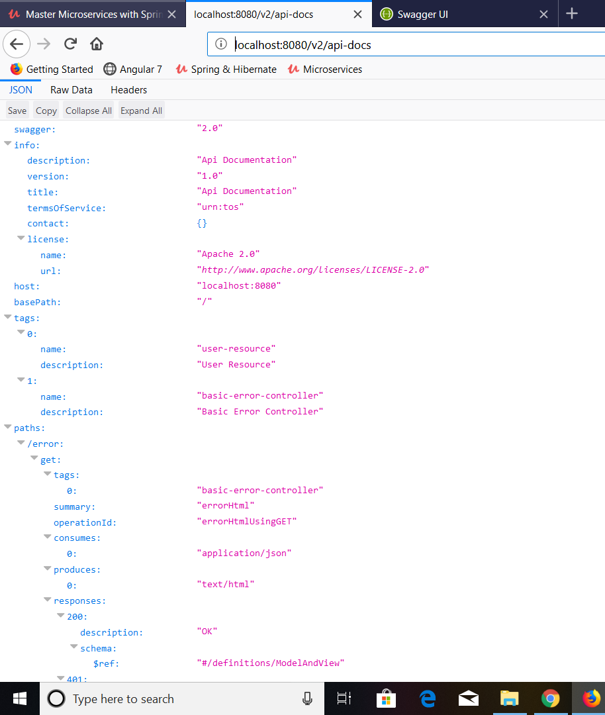

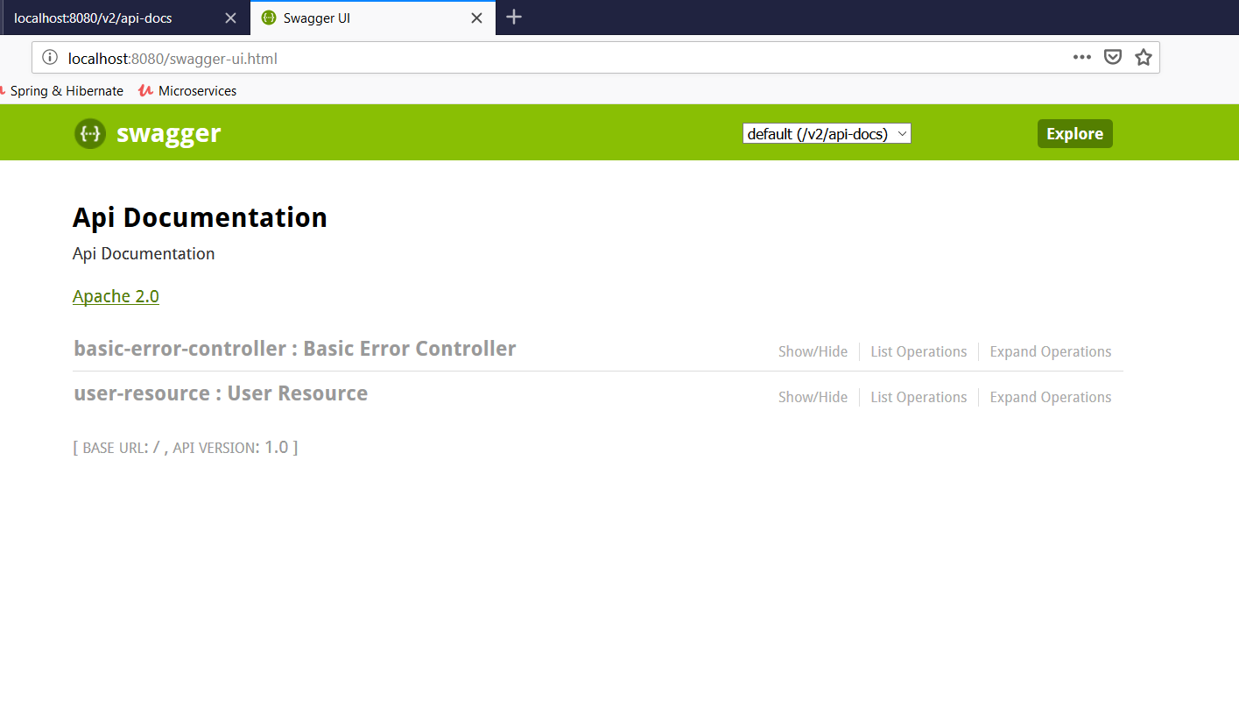

**To give extra information to Consumers we can program from Swagger config file.**

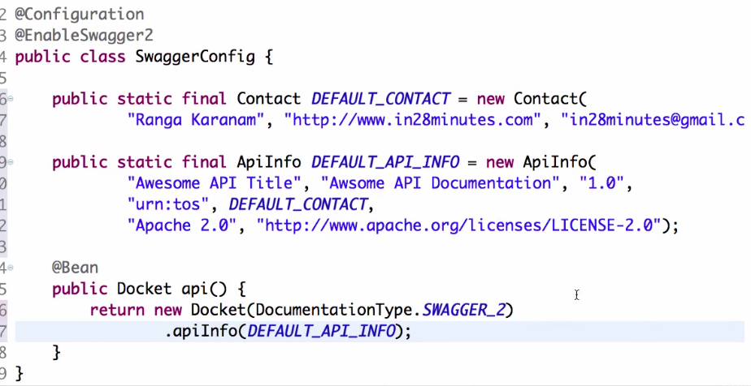

**What all it consumes and produces.**

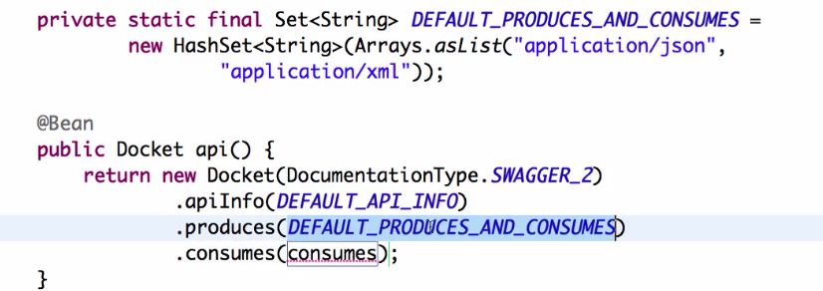

**To give the description about the objects.**

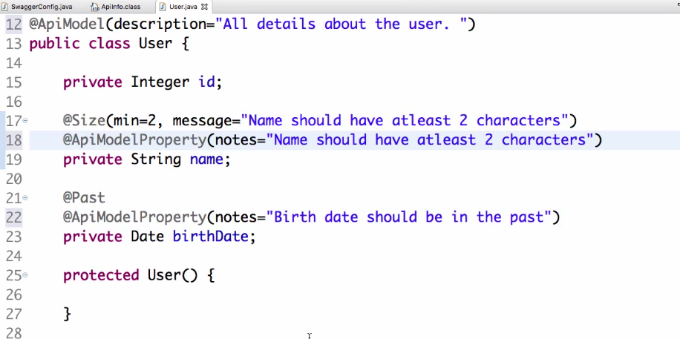

**Static Filtering:**

* From attributes in bean we can filter some specific content to end consumer. We can filter like password fields.
* We can @JsonIgnore annotation to filter specific field. So by this you can ignore only specific field all scenarios. This is called Static filtering

**Dynamic filtering:**

* If you want to ignore one particular field in one scenario and other field in another scenario, then we should go for dynamic filtering.
* Here we should configure the filter in the method where we send the response.
* We can create custom filters and give to MappingJacksonValue Object

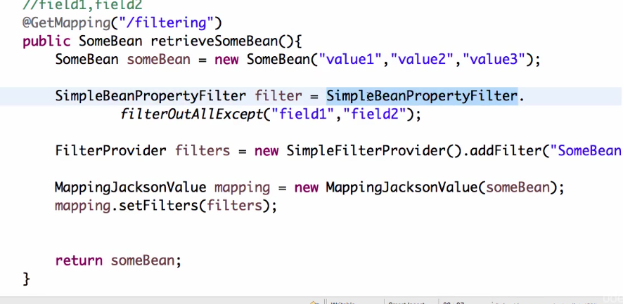

**Versioning:**

* giving different implementations for the services in different versions of API.
* **Versioning API Using URI:**

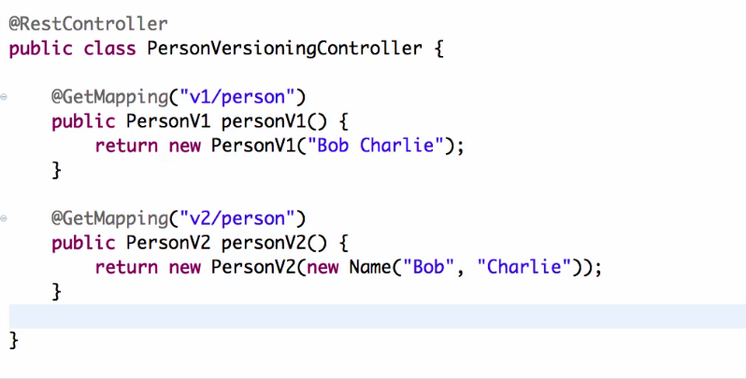

* **Versioning using Request parameter:**

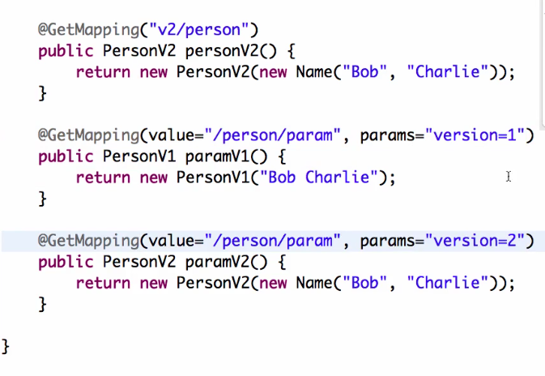

* **Versioning using Header:**

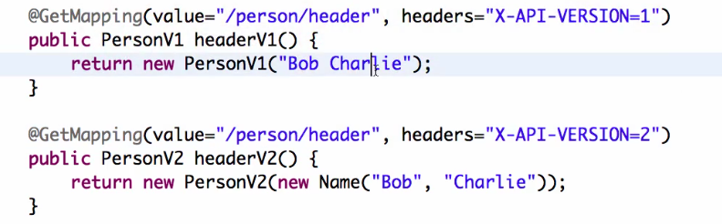

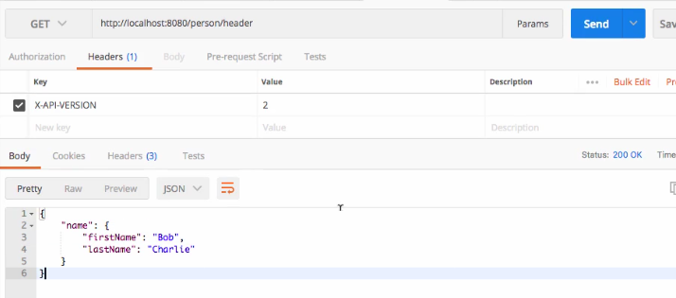

* **Versioning Using produces( Content negotiation or Accept Header versioning):**

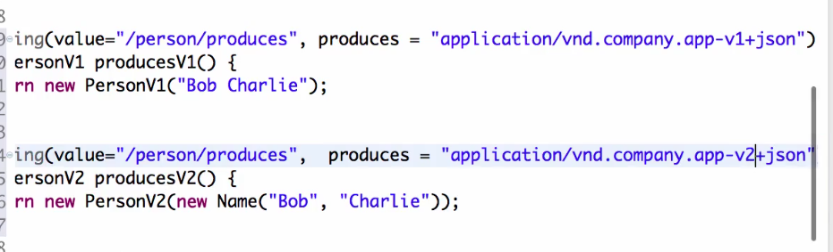

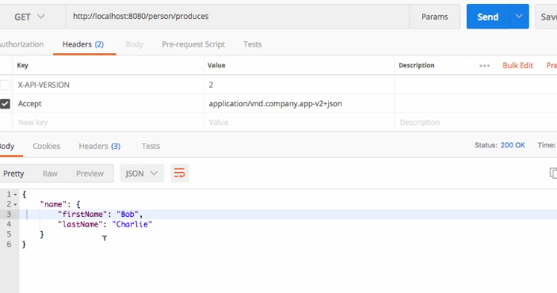

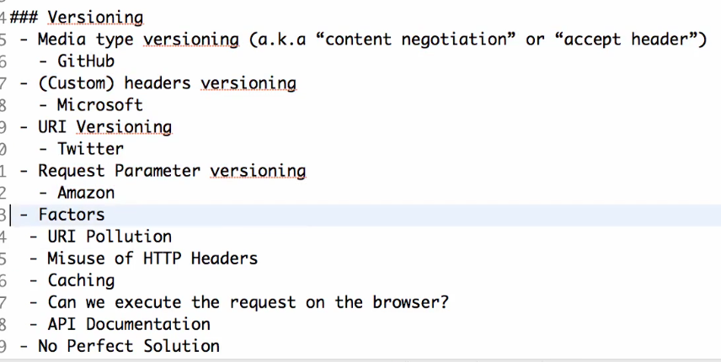

**Spring Security:**

* Implemented using servlet filters in the background.
* Two methods for securing web app: declarative and programmatic.
* Servlet filters used to pre-process and post process web requests and route them with some security logic.
* **Spring security filters will check the security configuration of the app such as users, passwords and roles and check if the user can access the web resource.**

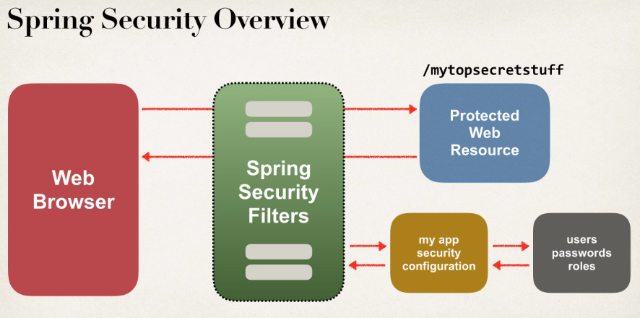

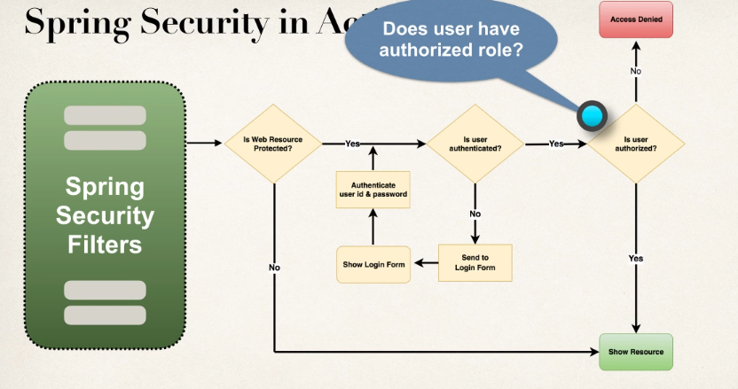

* To develop basic security, we need to create
  + Create Spring Security Initializer
  + create spring security configuration
  + Add users, passwords and roles.

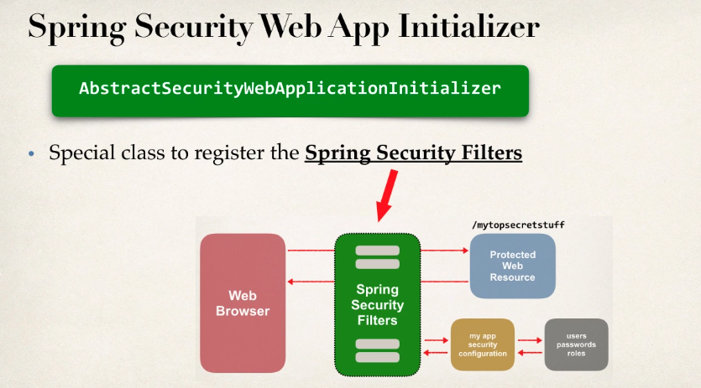

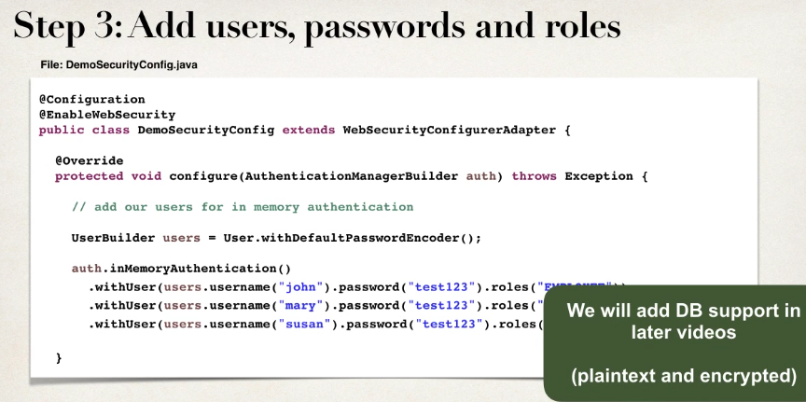

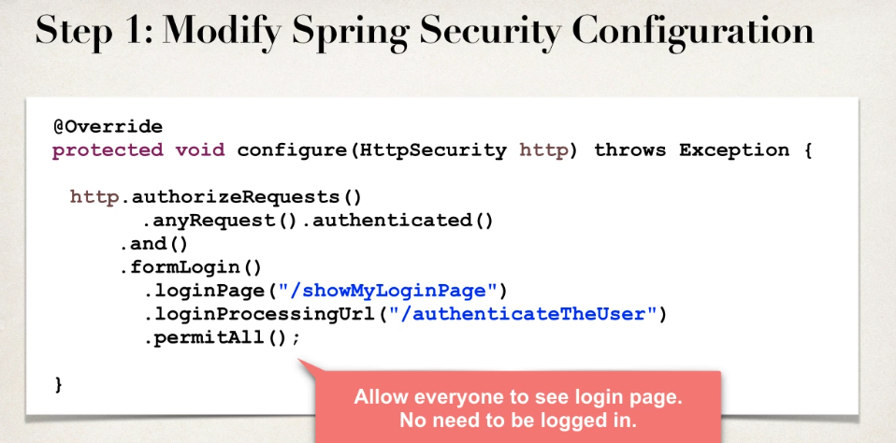

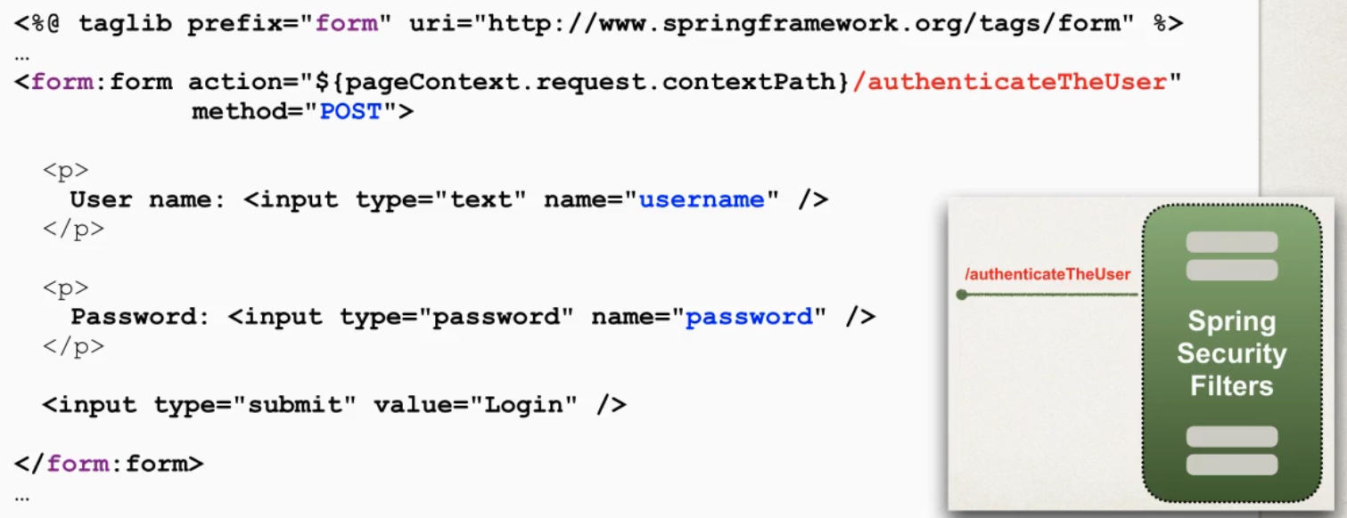

Spring will handle logout and login functionalities, just need to follow steps.

* Spring security protects from CSRF (cross site request forgery).
* We need to embed additional authentication data/tokens in to html forms, so that on subsequent requests web app will verify token before processing.

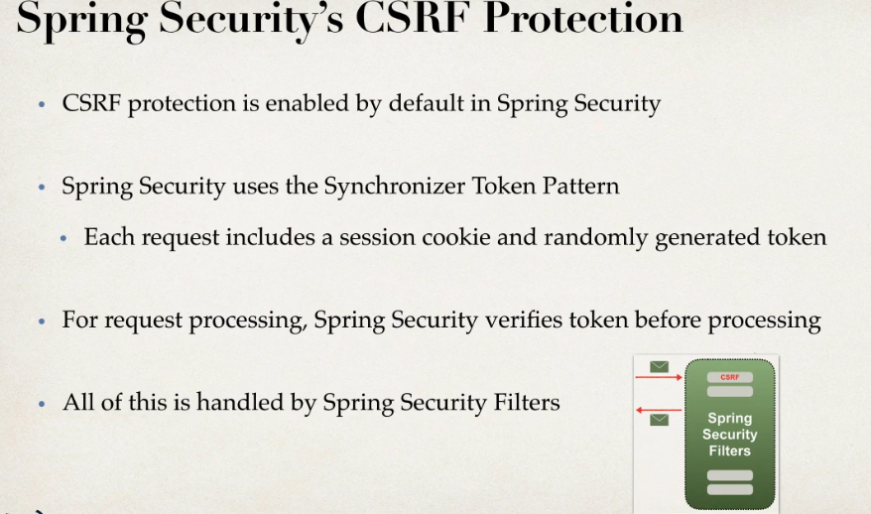

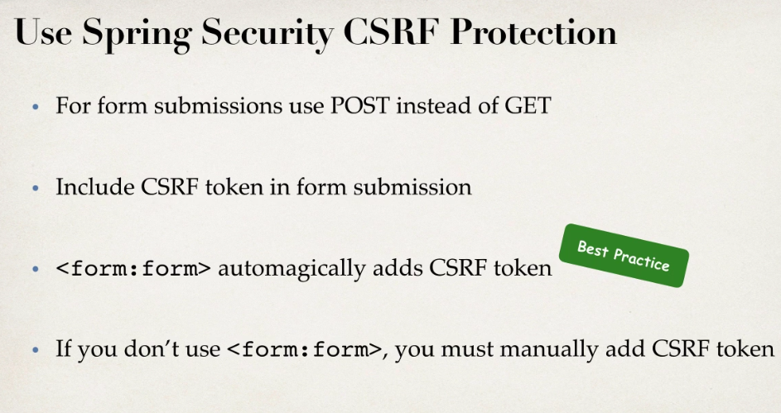

* We can set user id and roles and can display them using spring security JSP tag library.

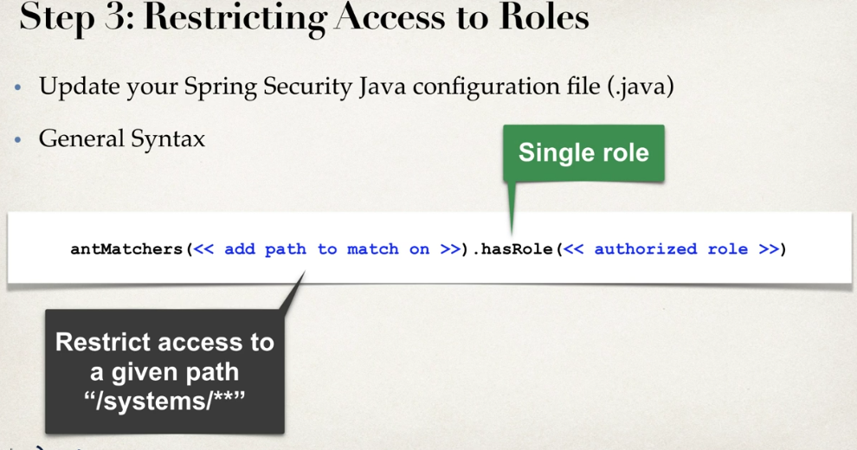

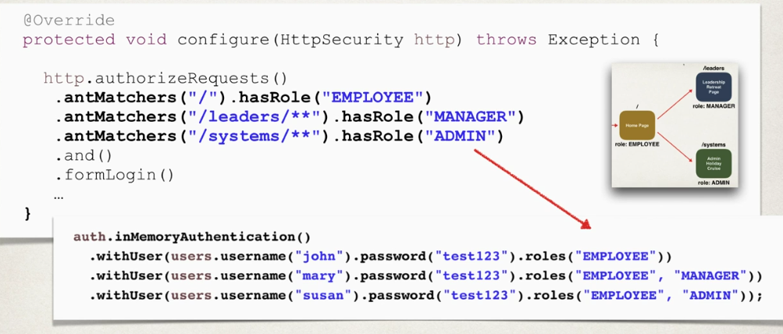

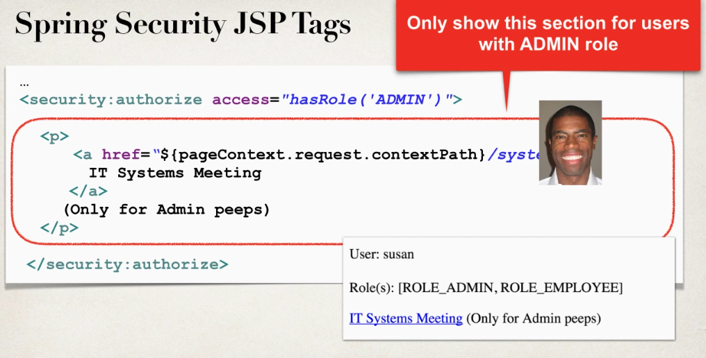

**Spring Boot:**

* Makes things easy to get started, because it minimizes the amount of manual configuration.
* It performs auto configuration based on prop files and JAR classpath.
* Helps to resolve dependency conflicts and provides an embedded HTTP server.

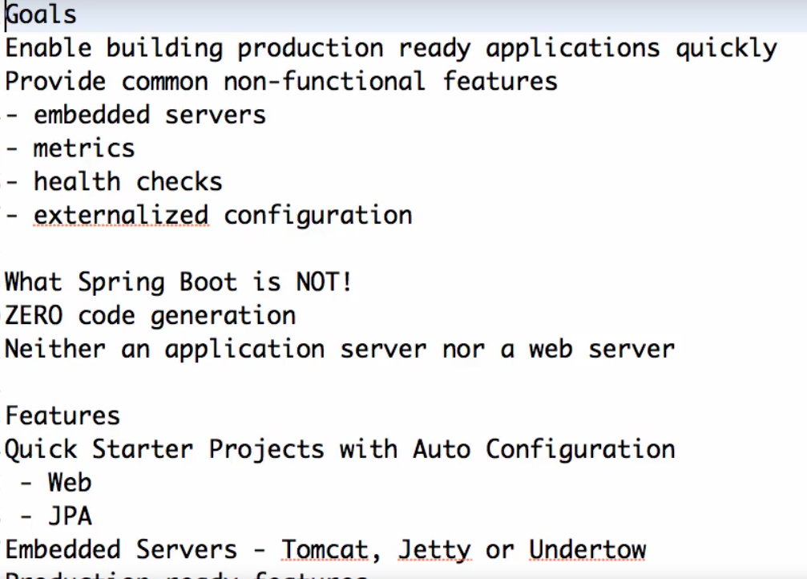

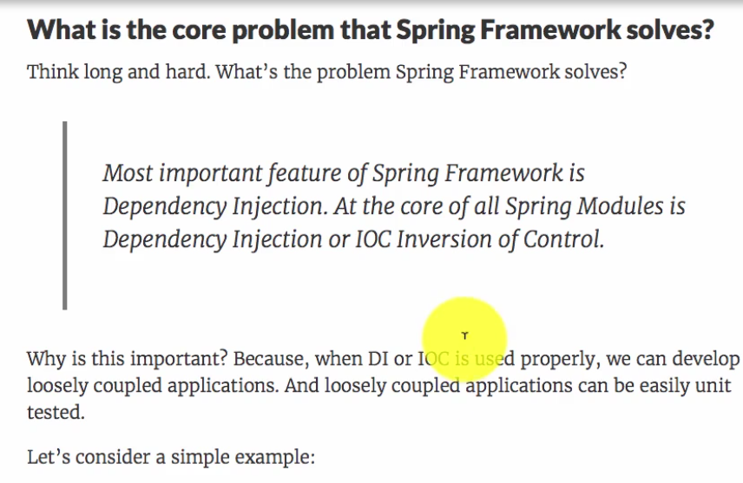

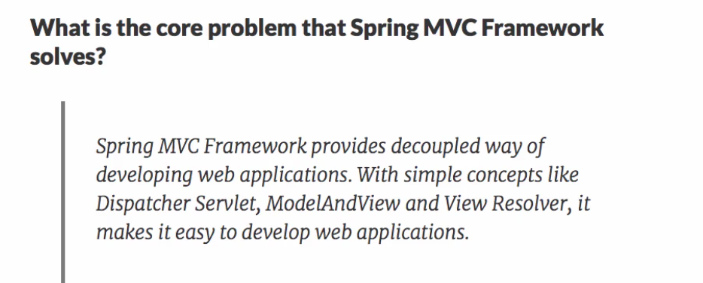

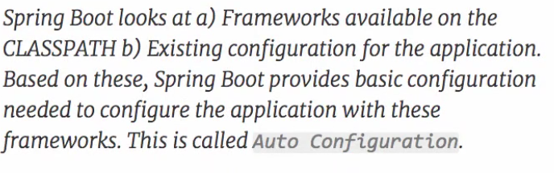

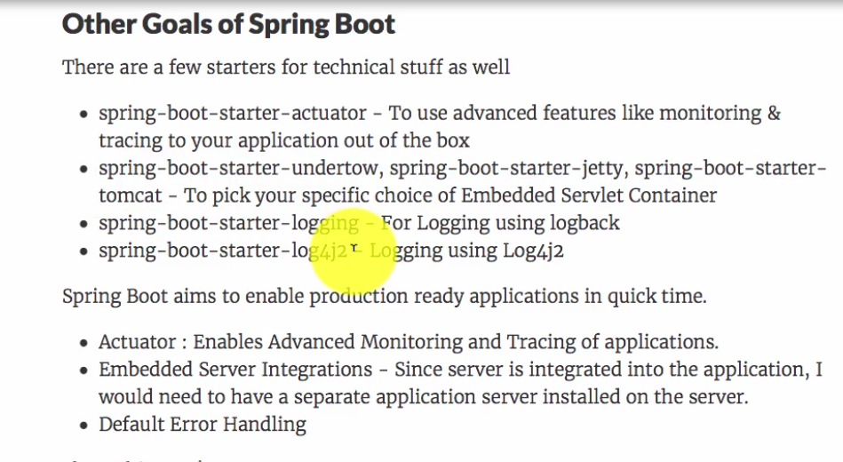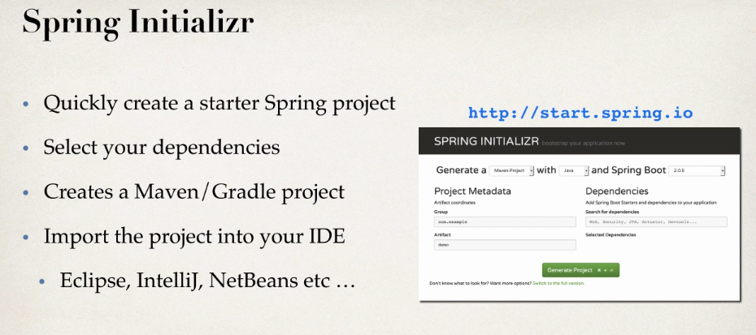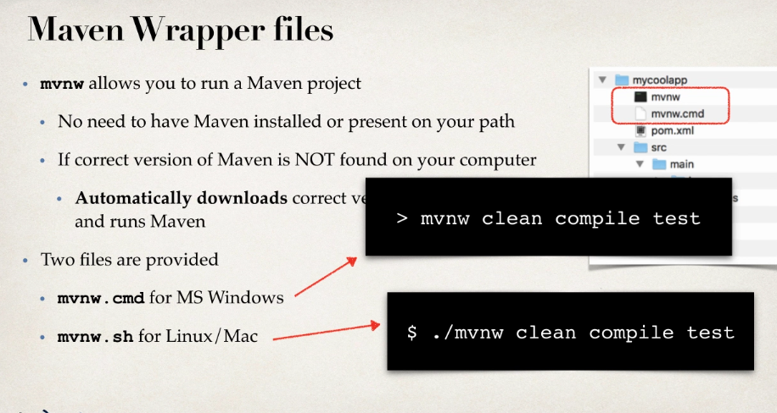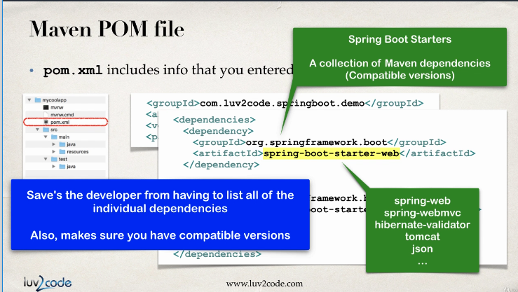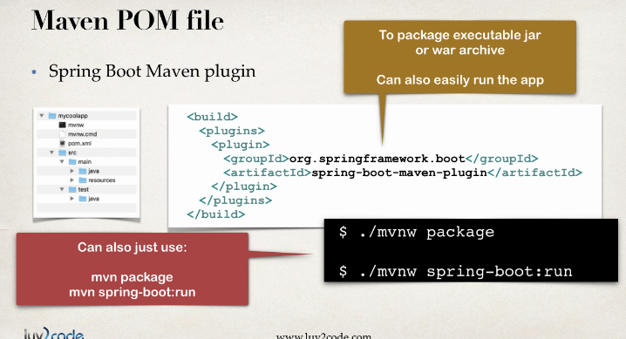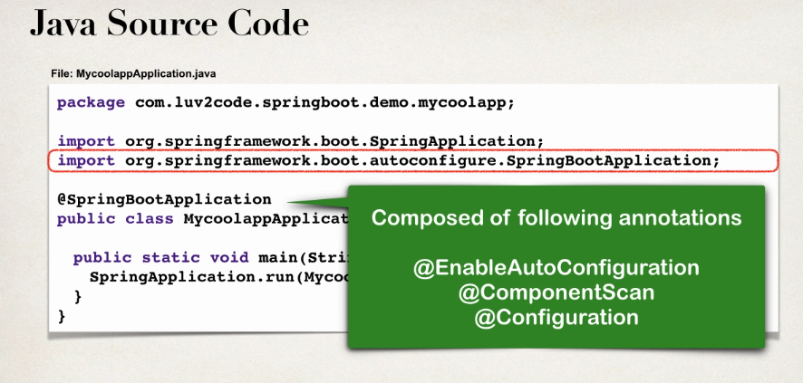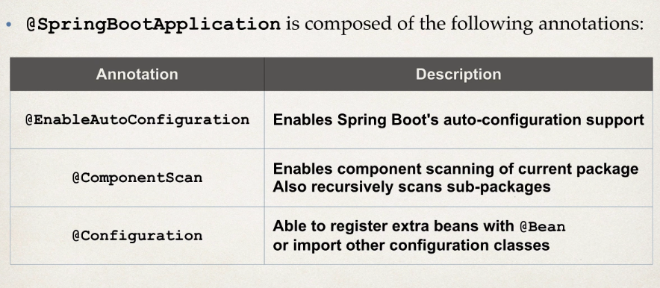

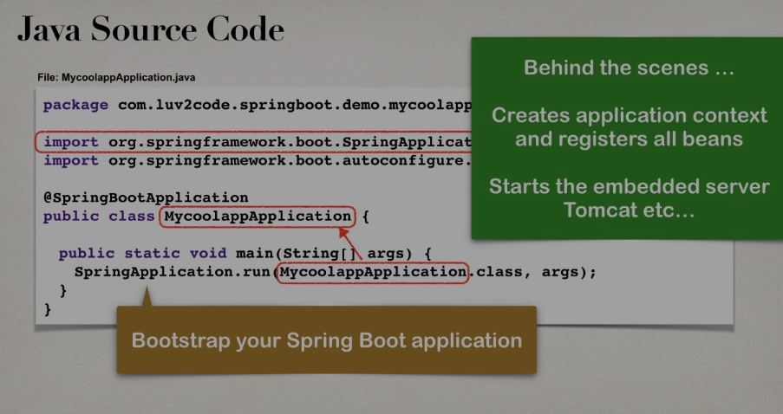

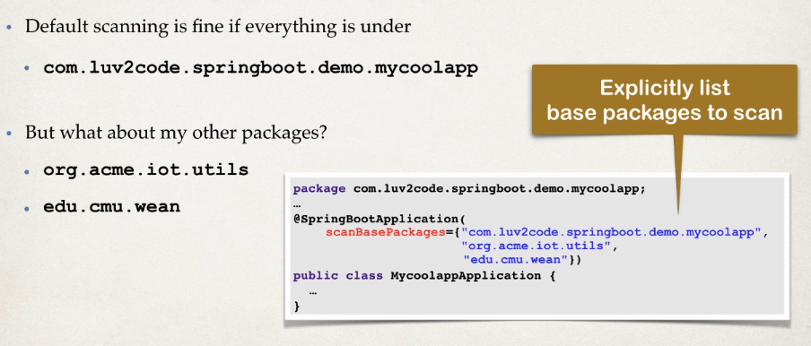

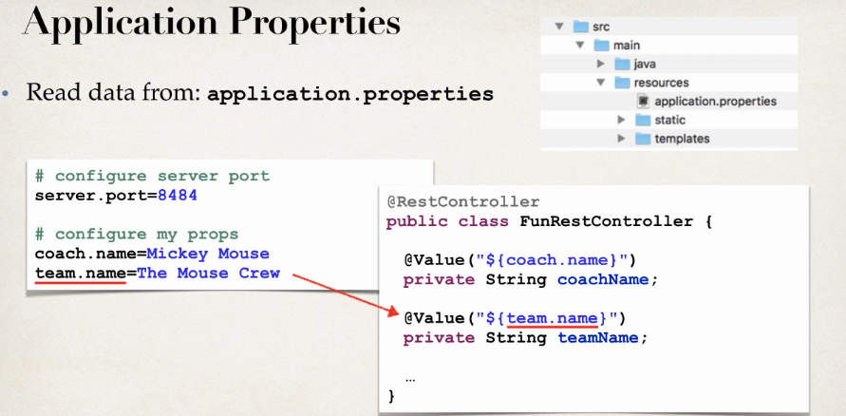

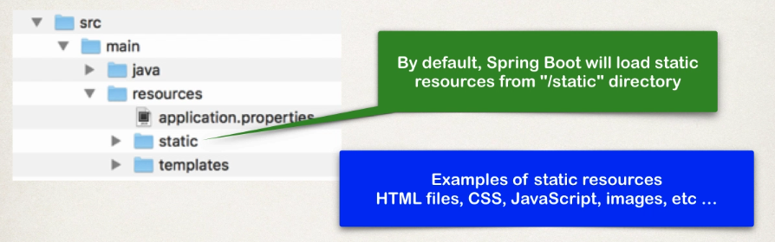

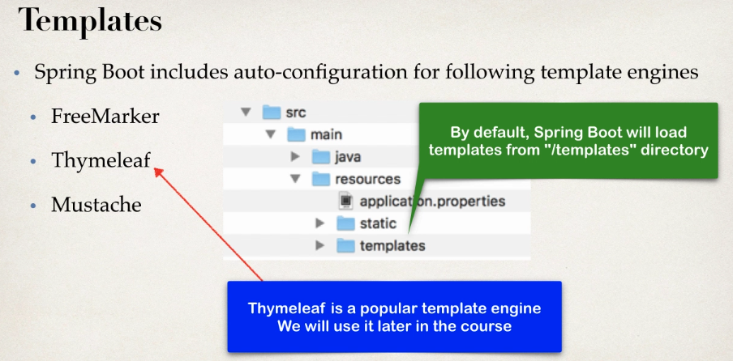

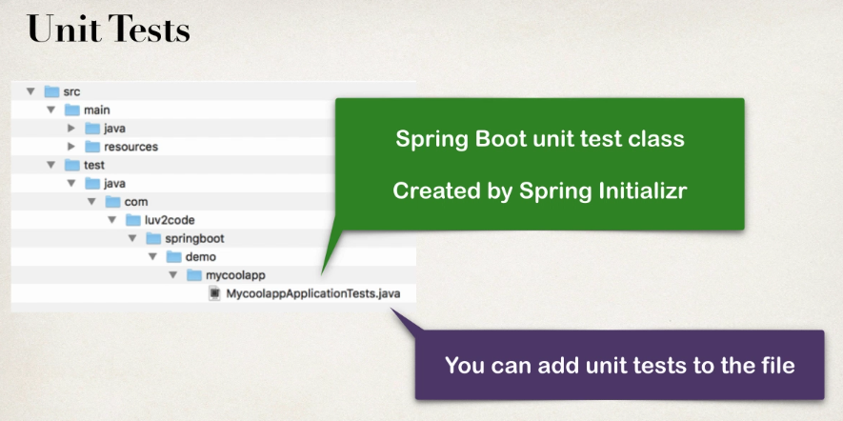

**Spring Boot starters:**

It is difficult to find all dependencies and their appropriate matching versions. So spring Boot will solve this by giving the following

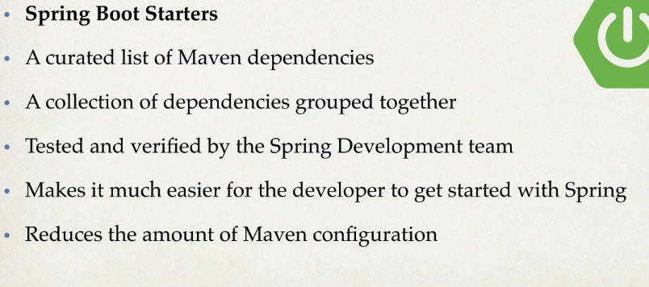

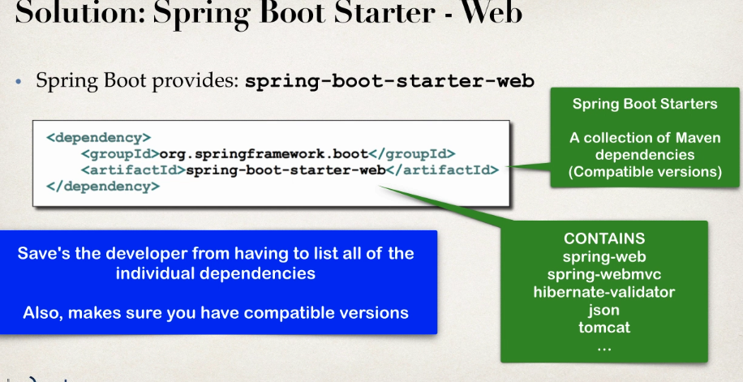

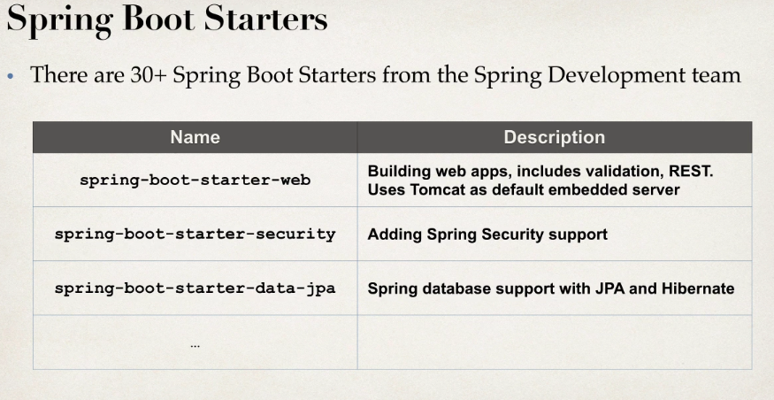

**Spring Boot Actuator:** These are configured to so that can check application health, info, beans and so on so that dev team can use some monitoring tools to check directly.

**Run from command line:**

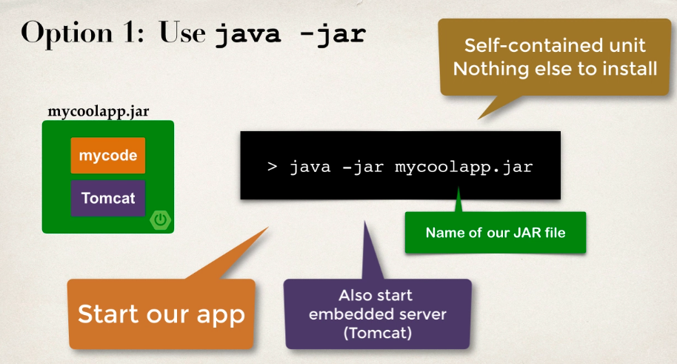

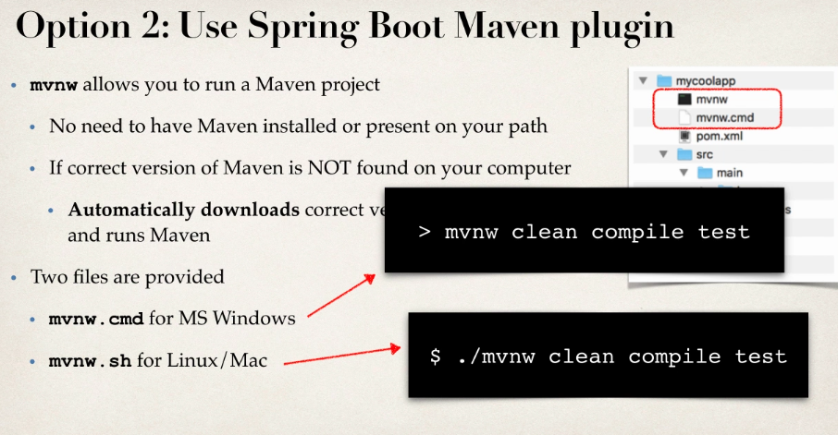

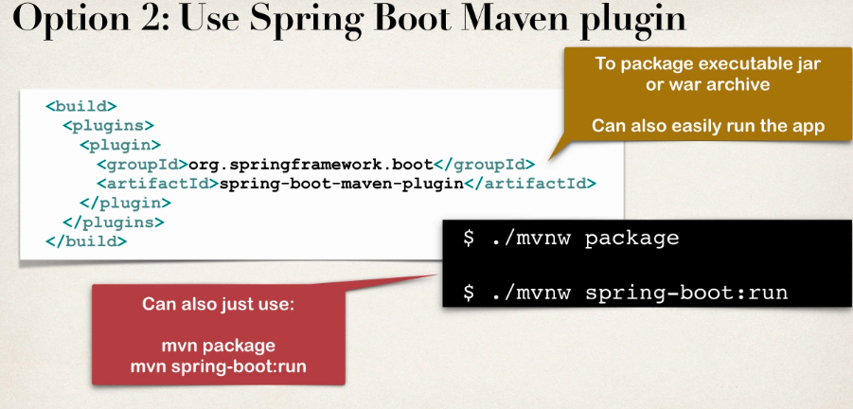

**Injecting Custom Application Properties:**

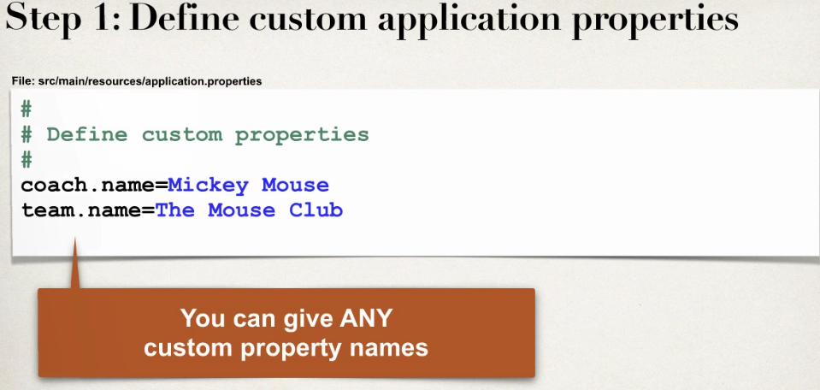

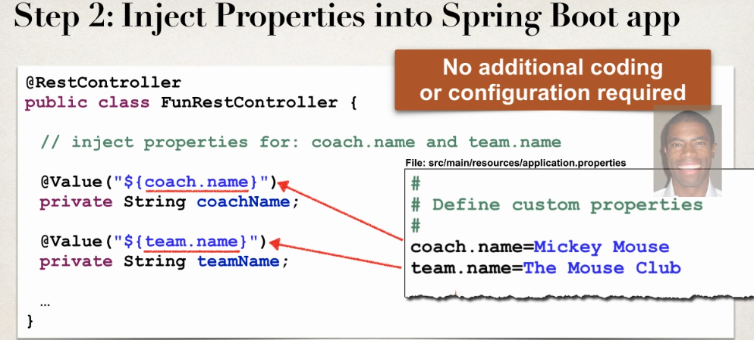

**Interview Questions:**

[**https://www.tutorialspoint.com/spring/spring_interview_questions.htm**](https://www.tutorialspoint.com/spring/spring_interview_questions.htm)

[**https://www.tutorialspoint.com/hibernate/hibernate_interview_questions.htm**](https://www.tutorialspoint.com/hibernate/hibernate_interview_questions.htm)

**a**

What are the ways to access Hibernate by using Spring?

There are two ways to access hibernate using spring −

* Inversion of Control with a Hibernate Template and Callback.
* Extending HibernateDAOSupport and Applying an AOP Interceptor node.

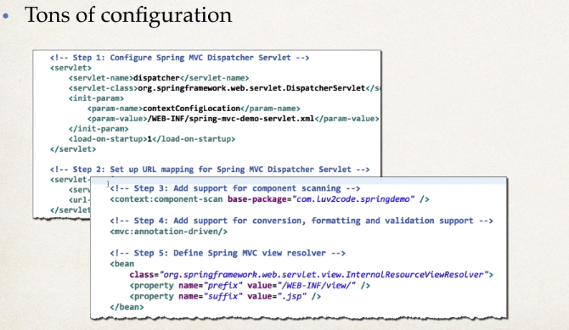

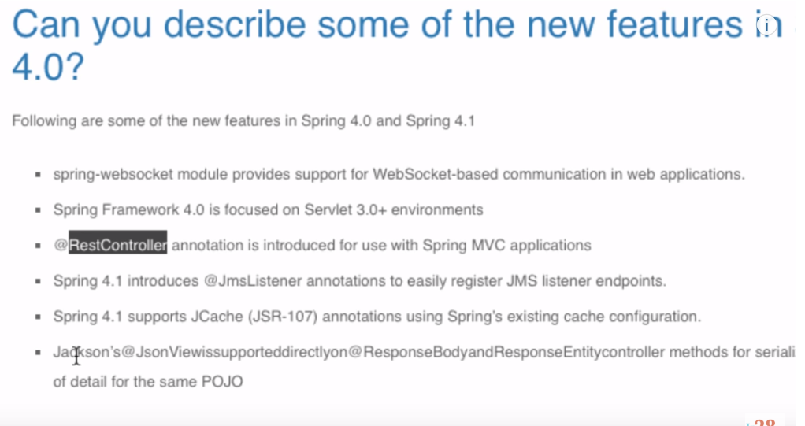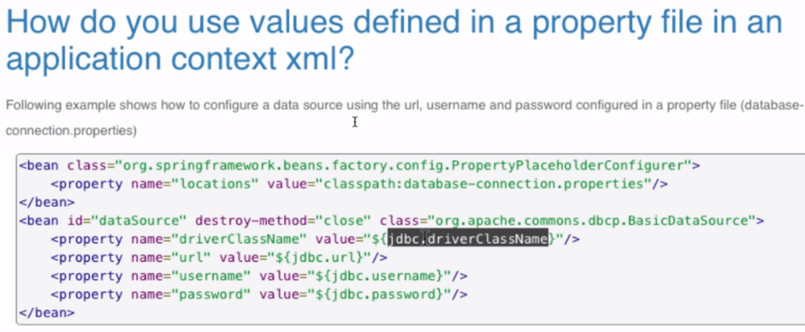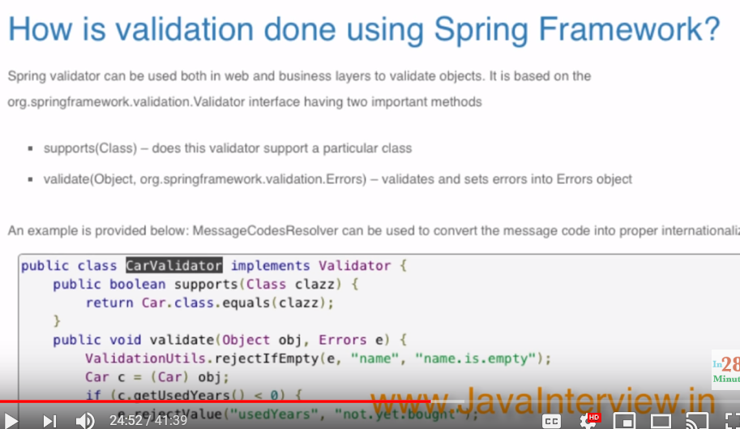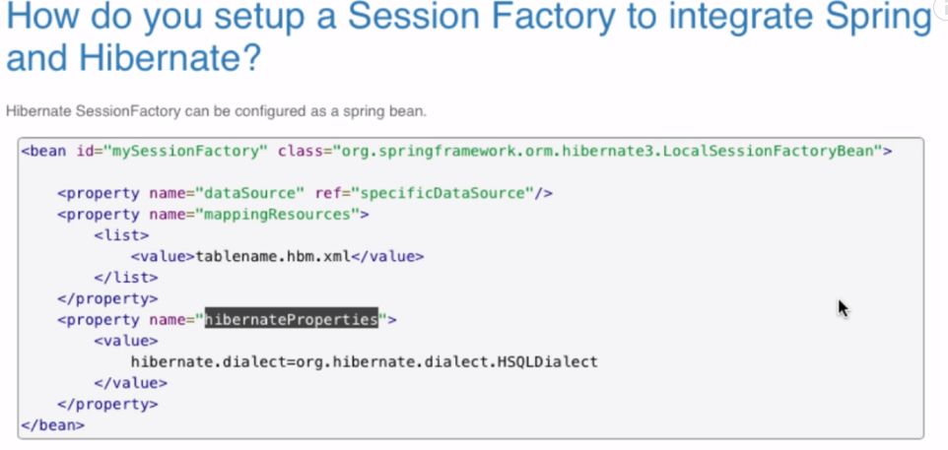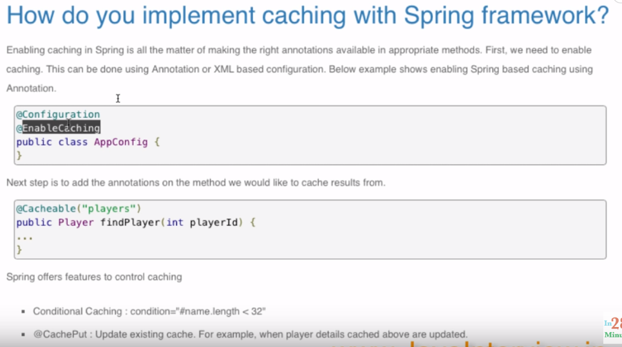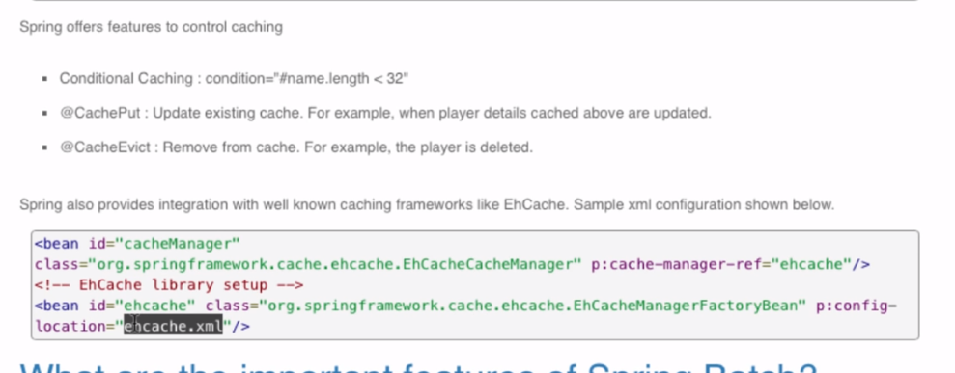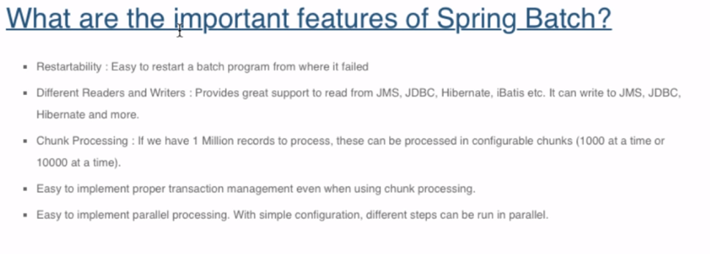

How does request flow happen in Spring MVC?

[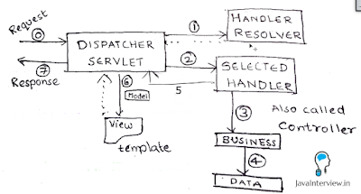](http://4.bp.blogspot.com/-iz_lkHWqkNM/VVDHgFUkLsI/AAAAAAAAAHY/i9l_PNDFe3U/s1600/Spring%2BMVC%2BRequest%2BFlow.png)

Shown in the picture below. DispatcherServlet acts as the front controller. Simplified actions taken by DispatcherServlet are listed below.

* All requests arrive at the DispatcherServlet (Front Controller) - STEP 0 in Figure
* DispatcherServlet resolves theme and locale as configured.
* Find’s appropriate Controller (Handler) to handle the request. (pre-processors and post-processors, if configured) (STEP 1)
* Redirect to the Controller (Handler) - STEP 2. Controller executes the request and returns a view name and a view model object. (STEP 3,4,5)
* DispatcherServlet resolves the view name and redirects to the view template. The response html is returned to DispatcherServlet. (STEP 6)
* DispatcherServlet send the response back to the browser. (STEP 7)

Can you list a few advantages of using Spring MVC framework?

* In Spring Web MVC, any POJO can be used as a command or form-backing object.
* Highly flexible databinding – If there is a type mismatch, it is shown as a validation error on the screen. Business POJO’s can directly be used as form-backing objects.
* Flexible view resolution: Controller can either select a view name and prepare model map for it or write directly to response stream.
* Supports JSP, Velocity and Freemarker view technologies.
* Can directly generate XML, JSON, Atom, and many other types of content.
* Highly convenient tag library.

Give examples of important Spring MVC annotations?

Important Spring MVC annotations are listed below.

* @Controller : This class would serve as a controller.
* @RequestMapping : Can be used on a class or a method. Maps an url on the class (or method).
* @PathVariable : Used to map a dynamic value in the url to a method argument.

Example 1 : Maps a url “/players “ for the controller method.

@RequestMapping(value="/players", method=RequestMethod.GET)

public String findAllPlayers(Model model) {

Example 2 : If a url /players/15 is keyed in, playerId is populated with value 15.

@RequestMapping(value="/players/{playerid}", method=RequestMethod.GET)

public String findPlayer(@PathVariable String playerId, Model model) {

Can you explain the concept of Interceptors in Spring MVC?

Handler interceptors are used when you want to apply specific functionality to certain requests. Handler Interceptors should implement the interface HandlerInterceptor.

Three methods are defined:

* preHandle(..) is called before the actual handler is executed;
* postHandle(..) is called after the handler is executed;
* afterCompletion(..) is called after the complete request has finished.

Interceptors can be configured using the interceptors property.

<bean id="handlerMapping" class="org.springframework.web.servlet.mvc.method.annotation.RequestMappingHandlerMapping">

<property name="interceptors">

<list>

<ref bean="yourCustomHandlerInterceptor"/>

</list>

</property>

</bean>

How do you schedule tasks with Spring?

Spring 3.0 introduced TaskScheduler abstract to deal with scheduling jobs. Spring has support for Timer (Jdk) and Quartz. Sample methods in the interface TaskScheduler are shown below:

ScheduledFuture scheduleAtFixedRate(Runnable task, long period);

ScheduledFuture scheduleWithFixedDelay(Runnable task, long delay);

Scheduling can also be done using an annotation

@Scheduled(fixedDelay=5000)

public void doSomething() {

// something that should execute periodically

}

Below example shows scheduling with xml configuration

<task:scheduler id="customScheduler" pool-size="30"/>

<task:scheduled-tasks scheduler=" customScheduler ">

<task:scheduled ref="someBean" method="someOtherMethod" fixed-delay="5000" initial-delay="1000"/>

<task:scheduled ref="someOtherBean" method="someMethod" cron="*/5 * * * * MON-FRI"/>

</task:scheduled-tasks>

How do you integrate Spring MVC with tiles?

Tiles helps us to define the layout for a web page. We can integrate Spring MVC with tiles by configuring TilesConfigurer and setting up appropriate view resolver.

<bean id="tilesConfigurer"

class="org.springframework.web.servlet.view.tiles2.TilesConfigurer"

p:definitions="/WEB-INF/tiles-defs/templates.xml" />

<bean id="tilesViewResolver"

class="org.springframework.web.servlet.view.UrlBasedViewResolver"

p:viewClass="org.springframework.web.servlet.view.tiles2.TilesView" />

How do you configure Spring MVC web application to use UTF-8 encoding for handling forms?

Using org.springframework.web.filter.CharacterEncodingFilter. Shown below.

<filter>

<filter-name>encoding-filter</filter-name>

<filter-class>

org.springframework.web.filter.CharacterEncodingFilter

</filter-class>

<init-param>

<param-name>encoding</param-name>

<param-value>UTF-8</param-value>

</init-param>

</filter>

<filter-mapping>

<filter-name>encoding-filter</filter-name>

<url-pattern>/*</url-pattern>

</filter-mapping>

How do you enable spring security for a web application?

Spring Security is used to implement Authentication and Authorization for a web application. We can enable spring security by configuring an appropriae security filter. Example shown below. We can create a separate security-context.xml to define the authentication and authorization roles and accesses.

<filter>

<filter-name>springSecurityFilterChain</filter-name>

<filter-class>

org.springframework.web.filter.DelegatingFilterProxy

</filter-class>

</filter>

<filter-mapping>

<filter-name>springSecurityFilterChain</filter-name>

<url-pattern>/*</url-pattern>

</filter-mapping>